**Sample Test of Brute Force Program**

1. **Inputs Given to the Program**

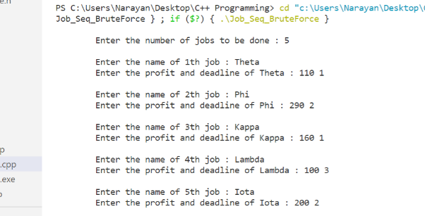

1. **Details of Input**

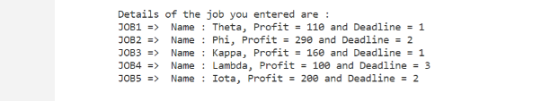

1. **Job Sequence for Maximum Profit, Maximum Profit and Time Taken in the Scheduling Process**

